**Airbnb Analysis – New York City**

Our group would like to perform an Airbnb analysis in one of the most dynamic cities in the world that is densely populated, world-class travel destination, and major financial hub.

**Questions:**

* What is the average price of listing for each neighborhood?
* Which neighborhoods have the best reviews?
* Where are the primary locations listed?
* How Airbnb is affected by Covid -19?
* What makes a superhost?

**Dataset:**

<http://insideairbnb.com/get-the-data.html> (New York City)

**Database:**

PostgreSQL, ElephantSQL

**Deployment App:**

Heroku

**API links:**

static/data/nyc.geojson

**Github Link:**

<https://github.com/kman4/Airbnb_analysis_NYC>

**Visualizations**

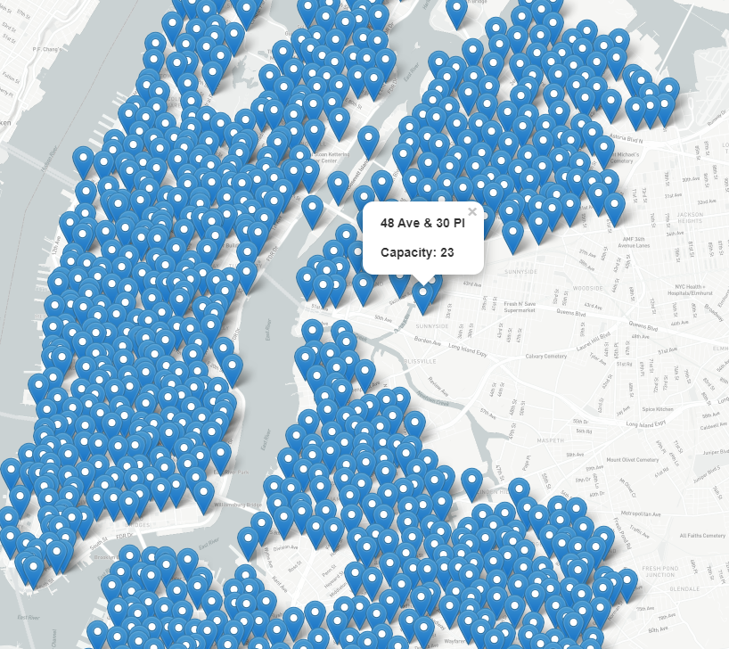

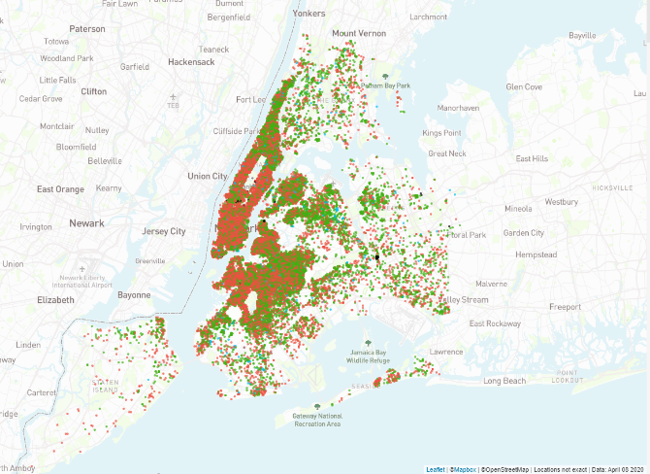

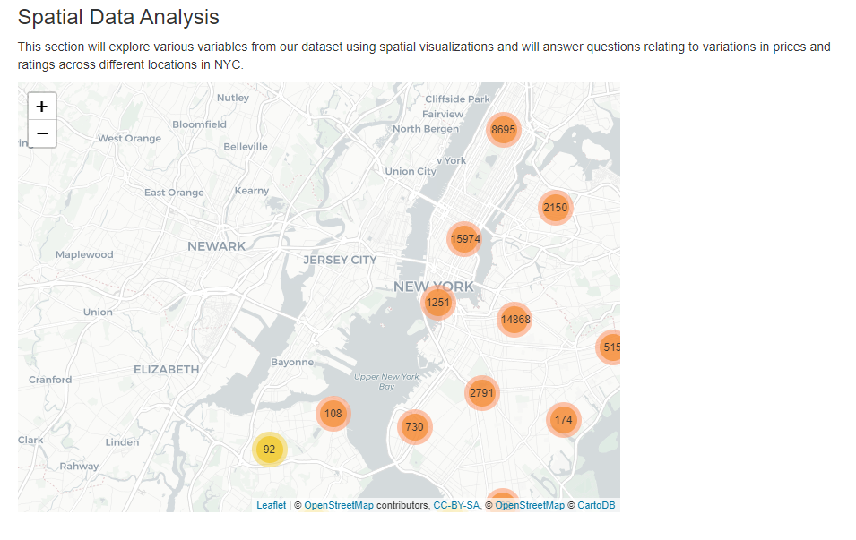

**Final Dashboard**

